1.2 OUTPUT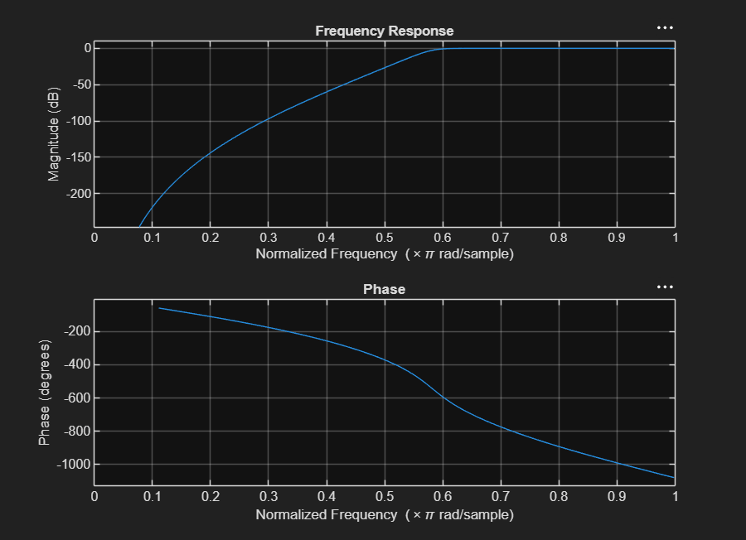
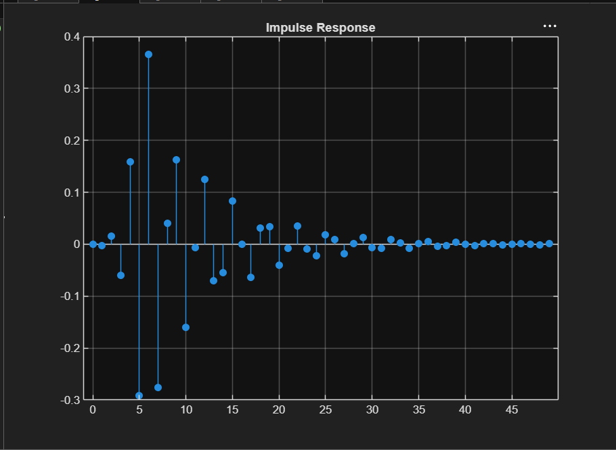

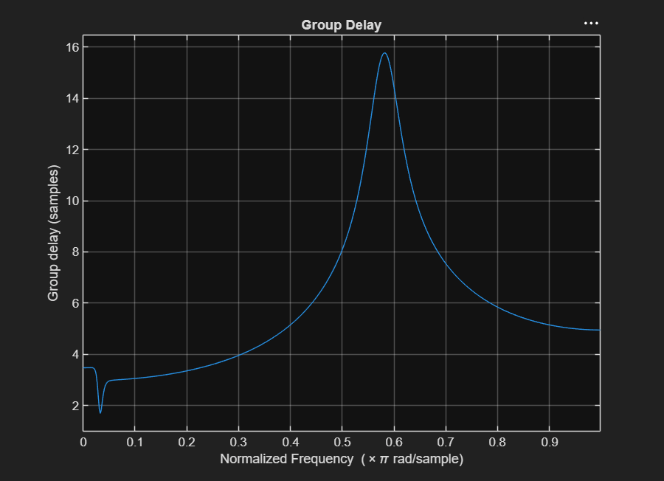
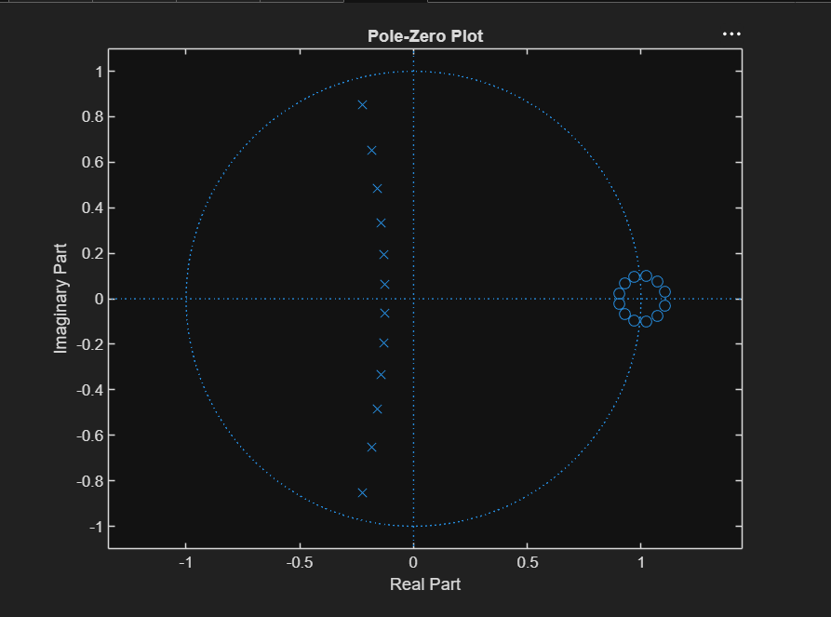

PROGRAM
clc;
clear;
close all;

% EX NO: 1
% Butterworth IIR Filters
% DATE:
% 1.2 Design and Analysis of a Butterworth IIR High-Pass Filter Using MATLAB

% Specifications
Fs = 10000; % Sampling Frequency (Hz)
Fp = 3000; % Passband Frequency (Hz)
Fst = 2000; % Stopband Frequency (Hz)
Rp = 1; % Passband Ripple (dB)
Rs = 60; % Stopband Attenuation (dB)

% Determine minimum filter order
[N, Wn] = buttord(Fp/(Fs/2), Fst/(Fs/2), Rp, Rs);

% Design Butterworth High-Pass Filter
[b, a] = butter(N, Wn, 'high');

% Frequency Response
figure;
freqz(b, a);
title('Frequency Response');

% Impulse Response
figure;
[h, n] = impz(b, a, 50);
stem(n, h, 'filled');
grid on;
title('Impulse Response');

% Step Response
figure;
stepz(b, a);
title('Step Response');

% Group Delay
figure;
grpdelay(b, a);
title('Group Delay');

% Pole-Zero Plot
figure;
zplane(b, a);
title('Pole-Zero Plot');

% Display Results
fprintf('Minimum Filter Order (N) = %d\n', N);
fprintf('Normalized Cutoff Frequency (Wn) = %.4f\n', Wn);
fprintf('Cutoff Frequency = %.2f Hz\n', Wn*(Fs/2));

